**BATCH FILE EXECUTION**

**AIM:**

To create a Windows batch file.

**PROCEDURE:**

Step 1 : Open a text file, such as a Notepad or WordPad document.

Step 2 :

Add your commands, starting with @echo [off], followed by, each in a new line, title [title of your batch script], echo [first line], and pause.

Step 3 : Save your file with the file extension BAT, for example, test.bat.

Step 4 : To run your batch file, double-click the BAT file you just created.

Step 5 : To edit your batch file, right-click the BAT file and select Edit.

And here's the corresponding command window for the example above:

# **1. Create a New Text Document**

A batch file simplifies repeatable computer tasks using the Windows command prompt. Below is an example of a batch file responsible for displaying some text in your command prompt. Create a new BAT file by right-clicking an empty space within a directory and selecting New, then Text Document.

# **1.CODE**

Double-click this New Text Document to open your default text editor. Copy and paste the following code into your text entry.

>> @echo off

>> echo hello

>> Pause

>> echo welcome

>> echo byee

>> pause

# 1**. TO SAVE a BAT File**

The above script echoes back the text "Welcome to batch scripting!" Save your file by heading to File > Save As, and then name your file what you'd like. End your file name with the added BAT extension, for example test.bat, and click OK. This will finalize the batch process. Now, double-click on your newly created batch file to activate it.

# **2. To RUN as BAT File**

Once you'd saved your file, all you need to do is double-click your BAT file. Instantly, your web pages will open. If you'd like, you can place this file on your desktop. This will allow you to access all of your favorite websites at once.

**OUTPUT:**

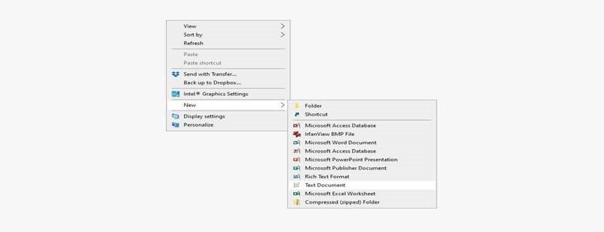

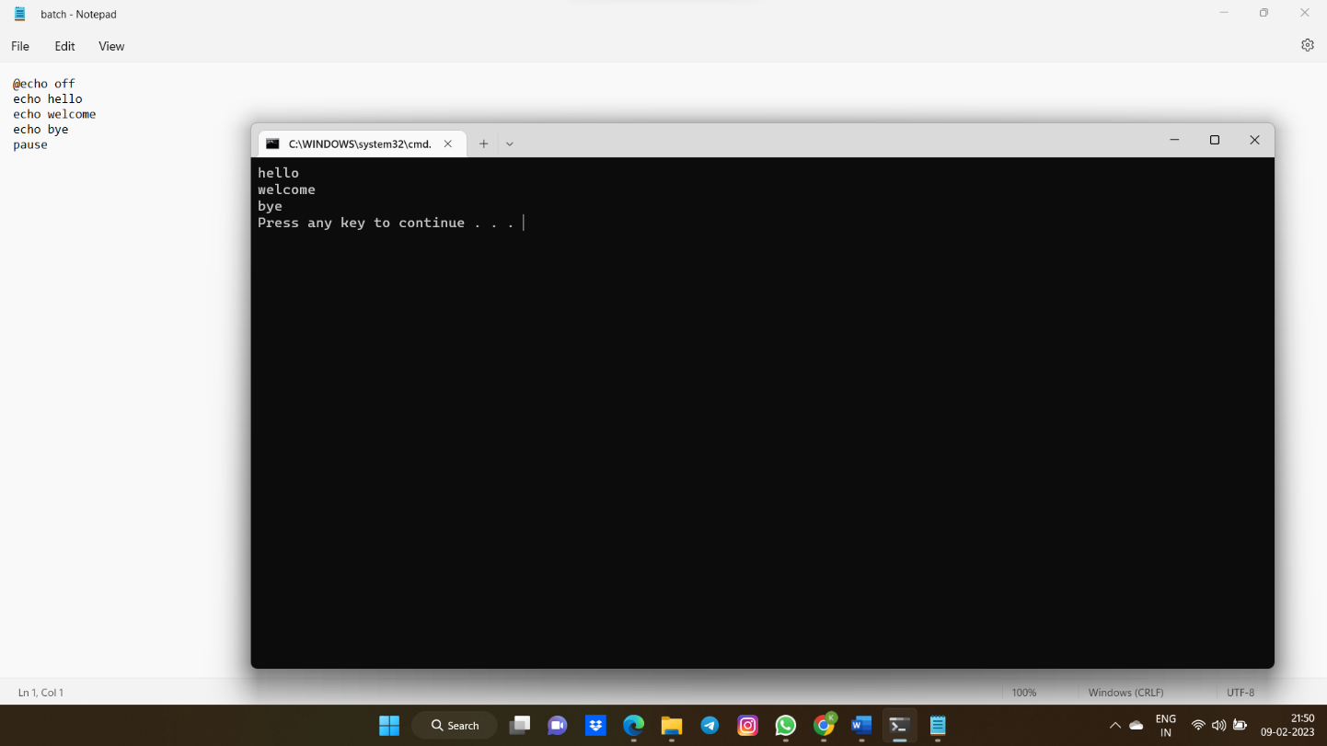

**RESULT:**

Thus the Creation and execution of BATCH FILE was successfully completed.